Duct Test Report

Testing Company | Name of Tester | Signature
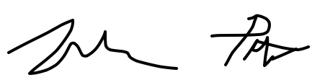
Home Address | Permit Number | GPIN
Conditioned Square footage | Source of Conditioned Square Footage | Number of HVAC Systems

TEST RESULTS
System 1
Duct tightness testing is not required. All ducts and the air handler are located entirely within the building thermal envelope.
Square Footage Served | Test Conditions | Maximum Allowed (CFM25) | Photo of Test Results on Gauge
Date | Test results (cfm@25pa) | Compliance Status
System 2
Duct tightness testing is not required. All ducts and the air handler are located entirely within the building thermal envelope.
Square Footage Served | Test Conditions | Maximum Allowed (CFM25) | Photo of Test Results on Gauge
Date | Test results (cfm@25pa) | Compliance Status

Notes

N1103.3.4 (R403.3.4) Duct Leakage (Prescriptive)
Test Conditions | Maximum Allowed Duct Leakage | Maximum Allowed (CFM25)
Rough-in with air handler installed | 4 CFM per 100 sq ft of conditioned floor area | .04 x conditioned floor area served
Rough-in without air handler installed | 3 CFM per 100 sq ft of conditioned floor area | .03 x conditioned floor area served
Post-construction | 4 CFM per 100 sq ft of conditioned floor area | .03 x conditioned floor area served




